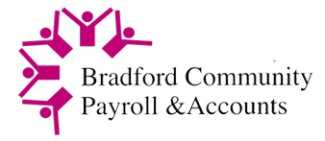  

An exciting opportunity has arisen in Bradford Community Payroll & Accounts,   
a trading arm of Community Action Bradford & District.

**Senior Finance Officer**

Full Time - 35 hours per week

£32,909 (NJC Payscale SO2) - AAT Level 4 or above

Bradford CPA Ltd provide a Payroll Bureau Service to primarily Voluntary & Community Sector (VCS) organisations and Direct Payment clients. We also provide a payroll service to Community Interest and Private companies.

We are looking for an experienced forward thinking Senior Finance Officer, who would be responsible for management accounts, client accounts and delivery of effective financial processes in a high-volume environment. They would also oversee our Finance Officer.

They will be responsible for the delivery of effective financial management across the organisation and have oversight of all systems and processes for directing, controlling and analysing financial resources.   
They would also be required to Deputise in the absence of the Manager.

This is an exciting position which requires the successful candidate to have excellent organisational skills and services development expertise.

In return we offer a competitive salary, pension, generous holidays and excellent working conditions.

The successful candidate must be willing to undergo a DBS check.

For further details please contact Maya Lad, Payroll & Business Manager on 01274 787800 or email [maya@bradfordcpa.co.uk](mailto:maya@bradfordcpa.co.uk).

# Closing Date: 2nd July 2023

Interviews will take place week commencing: 3rd July 2023

Application form, Job Description and Job Specification details can be accessed here:

<https://www.bradfordcpa.co.uk/news-job-opportunities/>