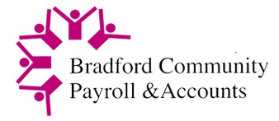

To: **CPA Clients**

**Employment Allowance**

With effect from 6th April 2025, HMRC have amended guidelines for claiming Employment Allowance.

This has been increased to £10,500 per annum, The allowance is designed to help eligible employers reduce their National Insurance (NI) liability.  This is an increase in the previous allowance of £5000.

If you have more than one PAYE scheme or have connected companies, only one claim can be made.

Please confirm that you would like us to claim this allowance on your behalf by completing and returning this form.

Please check your eligibility by looking at the guidance in the link below:

<https://www.gov.uk/claim-employment-allowance/eligibility>

Maya Lad

Payroll & Business Manager

I can confirm our organisation/company is eligible to claim Employment Allowance

Please claim the Employment Allowance of up to £10,500 on our behalf:

Name…………………………………………………………Title …………………………………………..

Signature ……………………………………………………Date……………………………………………

Organisation/Company………………………………………………………………………..………………

Please scan and return to [payroll@bradfordcpa.co.uk](mailto:payroll@bradfordcpa.co.uk)